MLA General Guidelines
- Type your paper on a computer and print it out on standard, white 8.5 x 11-inch paper,
- Double-space the text of your paper, and use a legible font like Times New Roman or Courier. The font size should be 10-12 pt.
- Leave only one space after periods or other punctuation marks (unless otherwise instructed by your instructor).
- Set the margins of your document to 1 inch on all sides. Indent the first line of a paragraph one half-inch (five spaces or press tab once) from the left margin.
- Create a header that numbers all pages consecutively in the upper right-hand corner, one-half inch from the top and flush with the right margin. (Note: Your instructor may ask that you omit the number on your first page. Always follow your instructor's guidelines.)
- Use either italics or underlining throughout your essay for the titles of longer works and, only when absolutely necessary, providing emphasis.
- If you have any endnotes, include them on a separate page before your Works Cited page.

Formatting the First Page of Your Paper
- Do not make a title page for your paper unless specifically requested.
- In the upper left-hand corner of the first page, list your name, your instructor's name, the course, and the date. Again, be sure to use double-spaced text.
- Double space again and center the title. Don't underline your title or put it in quotation marks; write the title in Title Case, not in all capital letters.
- Use quotation marks and underlining or italics when referring to other works in your title, just as you would in your text, e.g.,
  - Fear and Loathing in Las Vegas as Morality Play
  - Human Weariness in "After Apple Picking"
- Double space between the title and the first line of the text.
- Create a header in the upper right-hand corner that includes your last name, followed by a space with a page number; number all pages consecutively with Arabic numerals (1, 2, 3, 4, etc.), one-half inch from the top and flush with the right margin. (Note: Your instructor or other readers may ask that you omit last name/page number header on your first page. Always follow their guidelines.)

Here is a sample first page of an essay in MLA style:
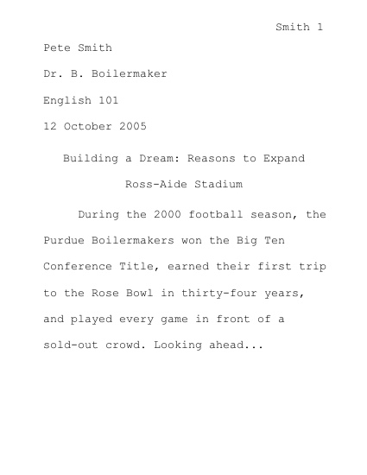
Cite the Purdue OWL in MLA:
Entire Website
The Purdue OWL. 26 Aug. 2008. The Writing Lab and OWL at Purdue
and Purdue University. 23 April 2008 <http://owl.english.purdue.edu>.
Individual Resources
Purdue OWL. "MLA Formatting and Style Guide." The Online Writing Lab at Purdue. 10 May
2008. Purdue University Writing Lab. 12 May 2008 <http://owl.english.purdue.edu/owl/resource/557/01/>.

